Hemagluttination Images For Practice:

Question 1:
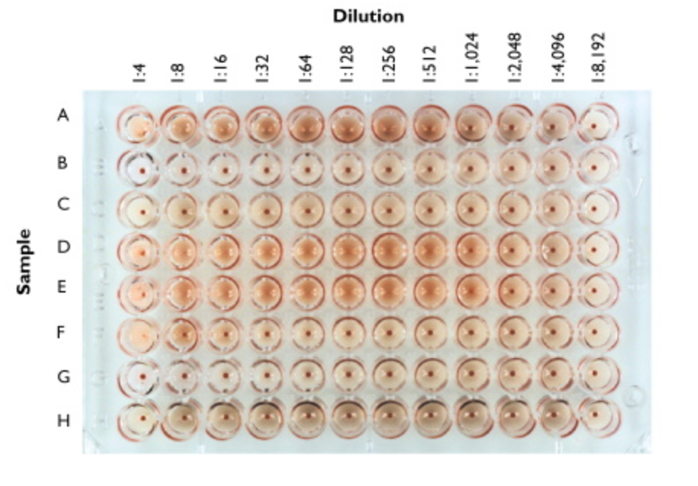
For the image above, each row (A-H) shows how one would determine the titer for antigens A, B, C, etc… NOTE: some antigens may not have enough dilutions to find the correct titer, so mark NA (not available) for those. Write down the titer for each of the rows here: (answers at end of page)

A - __________ E - __________

B - __________ F - __________

C - __________ G - __________

D - __________ H - __________

QUESTION 2:

The figure legend for the hemagglutination assay shown below is presented for you here.

Figure 4. Hemagglutination assay for influenza virus. Patient had blood drawn and their blood was centrifuged to remove cells. Two-fold dilutions of the serum were added to some sheep red blood cells and incubated at 37˚C. After an hour, the plate was removed from the incubator and scored for the titers of each.

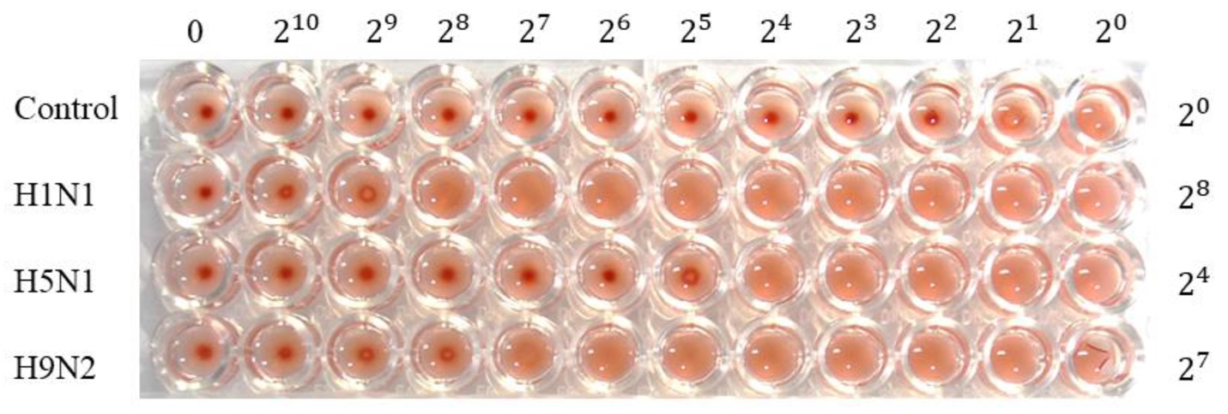

For this image:
- What does the control represent? Is it a positive or negative control? What is happening in the wells 2¹ and 2⁰ in the control lane?

- What does it mean to see a tight pellet of RBC on the bottom of the well in this particular case?

- What is the difference between the 0 and the 2⁰ wells?

- What is the Titer for the H1N1 _________? H5N1 __________? H9N2 __________?
(report these as a whole number, not an exponent)

Question 3

In the images below, a hemagglutination assay was preformed. From the image in A, you should be able to figure out what the titer was for each row. For this experiment, they report the titer based on the number of the column where the last activity is observed

For example.
The WT row represents a positive control. This means, we look for the last place we are able to see activity of this control and the activity being measured is hemagglutination (based on the HA titer (log₂)). I see that in well 7, more cells are pelleted than in lane 6 in the WT row. This tells me the last place where activity was observed was in lane 6. When I look at the figure B, it shows a HA titer of ≈5.8 with the little line on top of the black rectangle representing variations above the mean in multiple control experiments with WT.

So before looking at panel B, YOU determine the titers for each row, then compare your answers with what you see in Panel B.
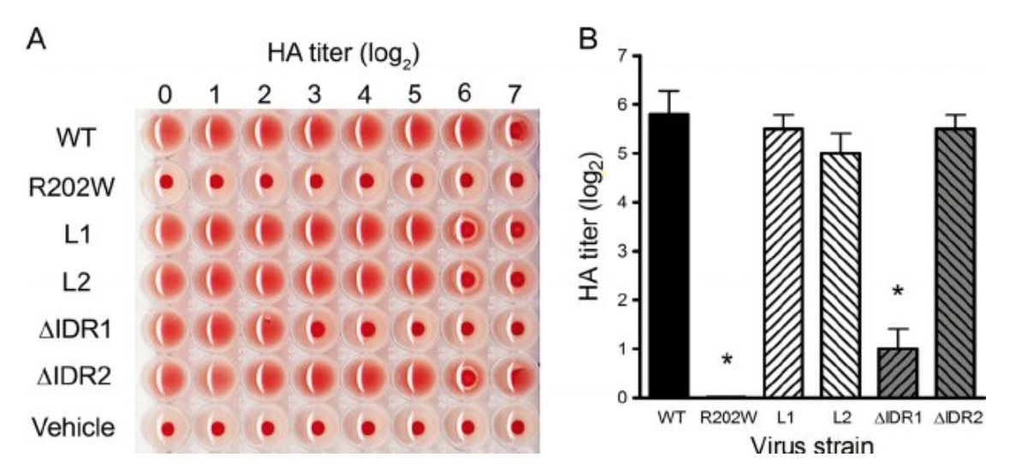

- What are the titers for:
  - WT ___6__________
  - R202W __________
  - L1 ______________
  - L2 ______________
  - dIDR1 ___________
  - DIDR2 ___________
  - Vehicle __________

- How good were your answers compared to the titers reported in panel B?
  - WT ___close to 5.8 mean__________
  - R202W __________
  - L1 ______________
  - L2 ______________
  - dIDR1 ___________
  - DIDR2 ___________
  - Vehicle __________

- What does Vehicle represent?

